**ARTIFICIAL INTELLIGENCE & MACHINE LEARNING**

**1. Introduction**

**Project Title:** Poultry Disease Detector  
**Team Members:**

* Nulu Devi Sri Lakshmi: Collecting dataset, Model Training, UI Design, Testing
* Mohana Maha Lakshmi: -
* Naga Trisha: -
* Pogiri Dolly: -

**2. Project Overview**

**Purpose:**  
To provide an AI-powered web application that helps farmers and researchers detect common poultry diseases using image classification.

**Features:**

* Upload image and predict disease
* Covers Coccidiosis, New Castle Disease, Salmonella, Healthy
* Confusion matrix, accuracy evaluation
* User-friendly web interface using Flask

**3. Architecture**

**Frontend:**

* HTML, CSS for structure and styling
* JavaScript used for interactivity (optional improvements suggested)

**Backend:**

* Flask app (app.py) that handles image uploads, model prediction, and routing

**Database:**

* No database used in current version (data handled locally)

**4. Setup Instructions**

**Prerequisites:**

* Python 3.10+
* Pip packages: Flask, TensorFlow, Keras, Pillow, NumPy

**Installation:**

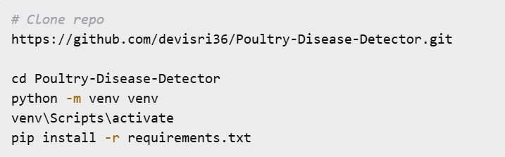

**5. Folder Structure**

**Client (UI & assets):**

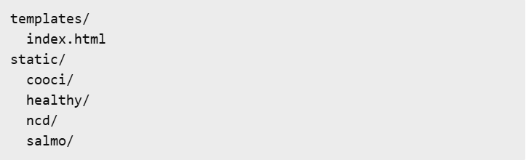

**Server (Backend & model):**

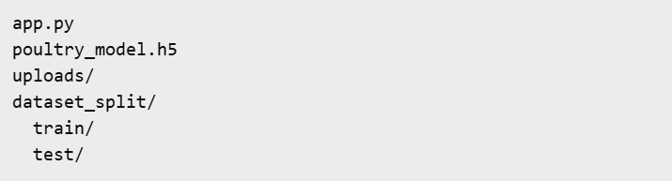

**6. Running the Application**

**Frontend:**

* Open browser and visit http://127.0.0.1:5000 after backend is running

**Backend:**



**7. API Documentation**

**POST /predict**

* **Request:** While we click choose file, it asks to choose file and upload. After uploading click predict. The disease predicted.

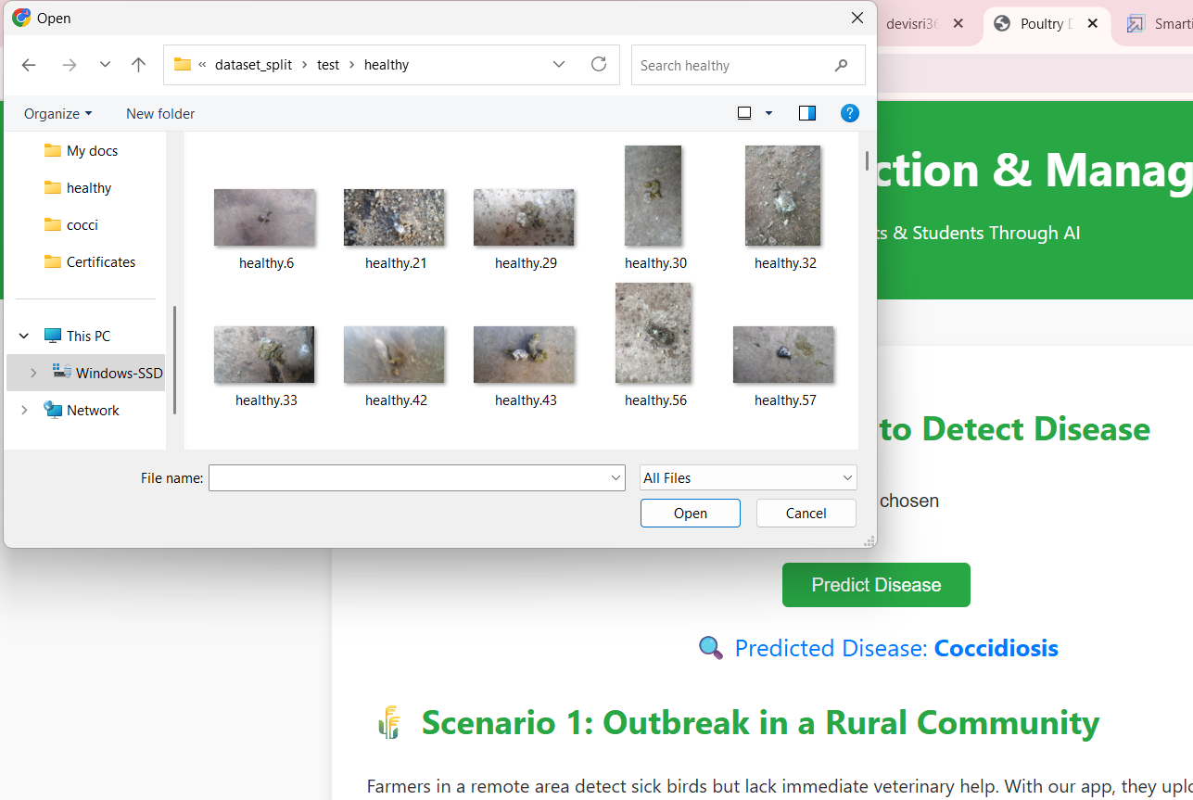

* **Response:** Predicted label from classes [Coccidiosis, Healthy, New Castle Disease, Salmonella]

**8. Authentication**

* Not applicable (no user authentication in this version)

**9. User Interface**

* Clean upload section
* Result display upon prediction
* Future improvements: Upload preview, dark mode

**10. Testing**

* Manual UI testing
* Evaluation on test set using classification report

**11. Screenshots or Demo**

* Web UI screenshot

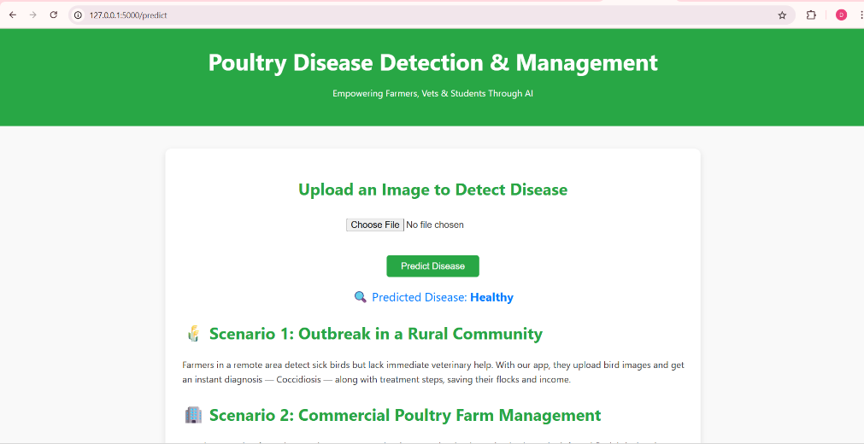

* Confusion matrix and classification report

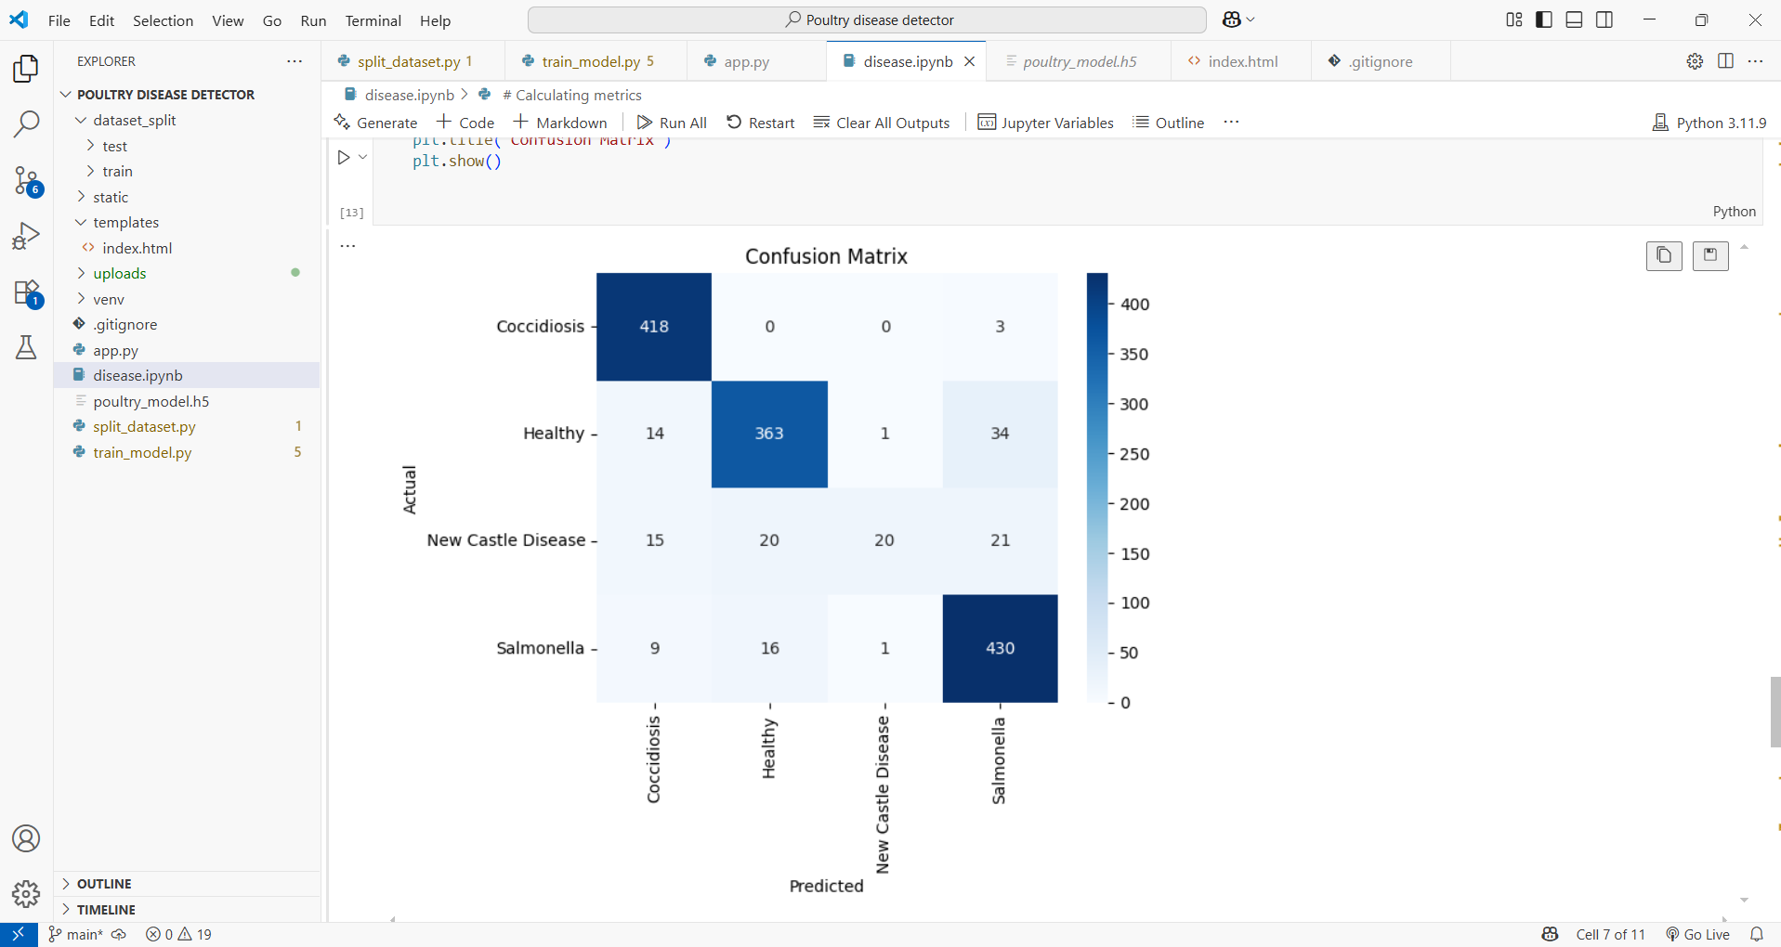

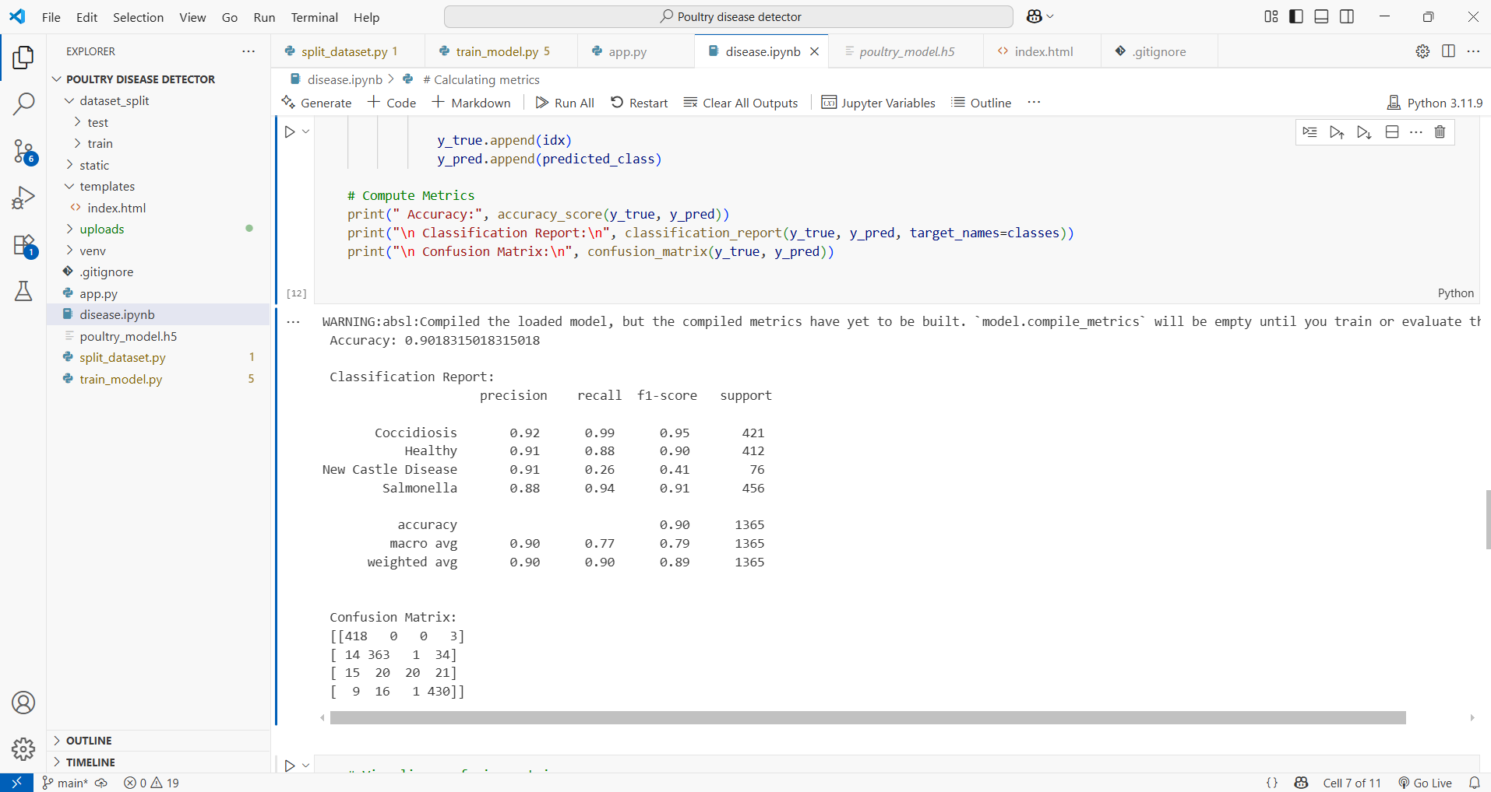

* GitHub Link: <https://github.com/devisri36/Poultry-Disease-Detector>
* Dataset Downloaded from here **-** <https://www.kaggle.com/datasets/kausthubkannan/poultry-diseases-detection>
* Demo Video link: <https://drive.google.com/file/d/1dsaZNM9htdj7158j5z-S13lP05fhhRXo/view?usp=sharing>

**12. Known Issues**

* Large file push to GitHub failed (solution: added .gitignore and manually managed files)
* Some misclassifications observed due to data imbalance

**13. Future Enhancements**

* Add login system and history for users
* Include real-time video frame predictions
* Extend model to detect more diseases
* Convert into Android mobile app